Nama : Jarot Setiawan

NIM : L200190247

Kelas/Matkul : D – PWD

* Css Bootstarp Data Mahasiswa
  + Code
* <?php
* session_start();
* *require*("function.php");
* *if*(!isset($_SESSION['login'])){
* header("Location:login.php");
* *exit*;
* }


* *//tekan tombol cari*
* *if*(isset($_POST['cari'])){
* $mahasiswa = cari($_POST['keyword']);
* } *else* {
* $mahasiswa = query("SELECT * from mahasiswa");
* }
* ?>
* <html>
* <head>
* <title>Jarot Setiwan L200190247</title>
* <link href="https://cdn.jsdelivr.net/npm/bootstrap@5.0.2/dist/css/bootstrap.min.css" rel="stylesheet" integrity="sha384-EVSTQN3/azprG1Anm3QDgpJLIm9Nao0Yz1ztcQTwFspd3yD65VohhpuuCOmLASjC" crossorigin="anonymous">
* </head>
* <body class="container">
* <h1 class="text-center mt-4">Daftar Mahaiswa</h1>
* <a href="logout.php" class="text-decoration-none text-danger fw-bold float-end"><svg xmlns="http://www.w3.org/2000/svg" width="16" height="16" fill="currentColor" class="bi bi-power" viewBox="0 0 16 16">
* <path d="M7.5 1v7h1V1h-1z"/>
* <path d="M3 8.812a4.999 4.999 0 0 1 2.578-4.375l-.485-.874A6 6 0 1 0 11 3.616l-.501.865A5 5 0 1 1 3 8.812z"/>
* </svg>Log out</a>
* <br>
* <br>
* <a href="tambah.php" class="text-decoration-none bg-primary text-white p-2">Tambah Data Mahasiswa</a>
* <br>
* <br>
* <form action="" method="post" class="text-center">
* <input type="text" name="keyword" size="40" autofocus placeholder="Masukkan kata pencarian" autocomplete="off" id="keyword">
* <button type="submit" name="cari" id="tombolCari" class="bg-warning border boder-0 py-1 px-2 text-white fw-bold">Cari</button>
* <a href="cetak.php" target="_blank" class="bg-success border boder-0 py-1 px-2 text-white fw-bold text-decoration-none">Cetak</a>
* </form>
* <br>
* <div id="container">
* <table border="1" cellpadding="10" cellspacing="0" class="text-center mx-auto table table-striped">
* <tr>
* <th>No</th>
* <th>Aksi</th>
* <th>NIM</th>
* <th>Nama</th>
* <th>Email</th>
* <th>Jurusan</th>
* <th>Gambar</th>
* </tr>
* <?php $i=1; ?>
* <?php *foreach* ($mahasiswa as $row): ?>
* <tr>
* <td><?= $i ?>.</td>
* <td><a href="edit.php?id=<?= $row['id'] ?>" class="text-primary text-decoration-none"><svg xmlns="http://www.w3.org/2000/svg" width="16" height="16" fill="currentColor" class="bi bi-pencil-fill" viewBox="0 0 16 16">
* <path d="M12.854.146a.5.5 0 0 0-.707 0L10.5 1.793 14.207 5.5l1.647-1.646a.5.5 0 0 0 0-.708l-3-3zm.646 6.061L9.793 2.5 3.293 9H3.5a.5.5 0 0 1 .5.5v.5h.5a.5.5 0 0 1 .5.5v.5h.5a.5.5 0 0 1 .5.5v.5h.5a.5.5 0 0 1 .5.5v.207l6.5-6.5zm-7.468 7.468A.5.5 0 0 1 6 13.5V13h-.5a.5.5 0 0 1-.5-.5V12h-.5a.5.5 0 0 1-.5-.5V11h-.5a.5.5 0 0 1-.5-.5V10h-.5a.499.499 0 0 1-.175-.032l-.179.178a.5.5 0 0 0-.11.168l-2 5a.5.5 0 0 0 .65.65l5-2a.5.5 0 0 0 .168-.11l.178-.178z"/>
* </svg>edit</a> | <a href="delete.php?id=<?= $row['id'] ?>" onclick="*return* confirm('Apakah yakin ingin menghapus data?')" class="text-danger text-decoration-none"><svg xmlns="http://www.w3.org/2000/svg" width="16" height="16" fill="currentColor" class="bi bi-trash" viewBox="0 0 16 16">
* <path d="M5.5 5.5A.5.5 0 0 1 6 6v6a.5.5 0 0 1-1 0V6a.5.5 0 0 1 .5-.5zm2.5 0a.5.5 0 0 1 .5.5v6a.5.5 0 0 1-1 0V6a.5.5 0 0 1 .5-.5zm3 .5a.5.5 0 0 0-1 0v6a.5.5 0 0 0 1 0V6z"/>
* <path fill-rule="evenodd" d="M14.5 3a1 1 0 0 1-1 1H13v9a2 2 0 0 1-2 2H5a2 2 0 0 1-2-2V4h-.5a1 1 0 0 1-1-1V2a1 1 0 0 1 1-1H6a1 1 0 0 1 1-1h2a1 1 0 0 1 1 1h3.5a1 1 0 0 1 1 1v1zM4.118 4 4 4.059V13a1 1 0 0 0 1 1h6a1 1 0 0 0 1-1V4.059L11.882 4H4.118zM2.5 3V2h11v1h-11z"/>
* </svg>delete</a></td>
* <td><?= $row["nim"] ?></td>
* <td><?= $row["nama"] ?></td>
* <td><?= $row["email"] ?></td>
* <td><?= $row["jurusan"] ?></td>
* <td><img src="asset/img/<?= $row["gambar"] ?>" width="50"></td>
* <?php $i++ ?>
* </tr>
* <?php *endforeach* ?>
* </table>
* </div>
* <script type="text/javascript" src="js/script.js">
* </script>
* </body>
* </html>
  + Hasil

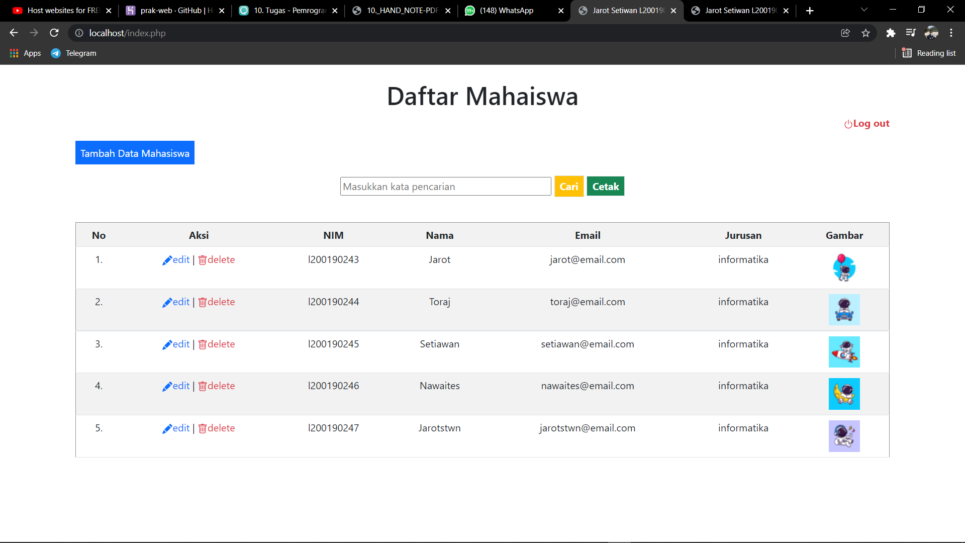

* Pdf Formating
  + Code
* <?php
* *//mengambil libarary mpdf dari folder vendor*
* *require_once* __DIR__ . '/vendor/autoload.php';
* *//ambil data dari database*
* $conn = mysqli_connect ('localhost','root','','kuliah');
* $cari = "SELECT * FROM mahasiswa";
* $mahasiswa = mysqli_query($conn, $cari);
* *//membuat file pdf baru*
* $mpdf = new \Mpdf\Mpdf();
* *//isi dokumen yang dicetak*
* $html = '<html>
* <head>
* <title>Jarot Setiwan L200190247</title>
* </head>
* <body class="container">
* <h1 class="text-center mt-4">Daftar Mahasiswa</h1>
* <div id="container">
* <table border="1" cellpadding="10" cellspacing="0">
* <tr>
* <th>No</th>
* <th>NIM</th>
* <th>Nama</th>
* <th>Email</th>
* <th>Jurusan</th>
* <th>Gambar</th>
* </tr>';
* $i=1;
* *foreach* ($mahasiswa as $row){
* $html .= '<tr>
* <td>'.$i++.'</td>
* <td>'.$row["nim"].'</td>
* <td>'.$row["nama"].'</td>
* <td>'.$row["email"].'</td>
* <td>'.$row["jurusan"].'</td>
* <td><img src="asset/img/'.$row["gambar"].'" width="50"></td>
* </tr>';
* };
* $html .='</table>
* </div>
* </body>
* </html>';
* *//mencetak pdf dengan $html adalah dokumen isiannya*
* $mpdf->WriteHTML($html);
* *//menyimpan dalam format pdf*
* $mpdf->Output();
* ?>
  + Hasil di mpdf.pdf